Iftiar Rana’s Brief Analysis on Dragon Ball Super Tournament of Power

**SPOILER WARNING AHEAD**

**Introduction**

In the anime, *Dragon Ball Super*, two omnipotent beings both named Zeno (one from the current timeline and the other from a future timeline) host a tournament called The Tournament of Power. This is a test of 8 universes they deem weak based off a mortal scale level to see how strong they really are. The essence of it is ten fighters from each universe have to eliminate every other fighter from a different universe to survive. When a universe has all of its fighters out of the ring, they are erased. The survivor would be granted any wish they desire.

The purpose of this report is to study how many people each universe and fighter eliminated.

**Method**

Initially I used the Dragonball Fandom Wiki to find the roster and the order of elimination in the anime. I copied it verbatim on an Excel spreadsheet. However, when I saw the episodes for this tournament saga, I noticed there are fighters who ultimately eliminating themselves. An elimination is when a fighter is thrown out of the ring directly by another fighter’s action. I created another category called “Self” (short for self-elimination) and defined it as fighters who willingly went over the ring and got themselves eliminated. Therefore, I had to slightly tweak the “Eliminated By” column and having “Self” as an option to reflect that. I also added a “Collab” option because some fighters needed at least 2 other fighters to be eliminated.

I then used RStudio to code and create the first 2 graphs seen in the next section and Tableau for the final graph.

**Results**

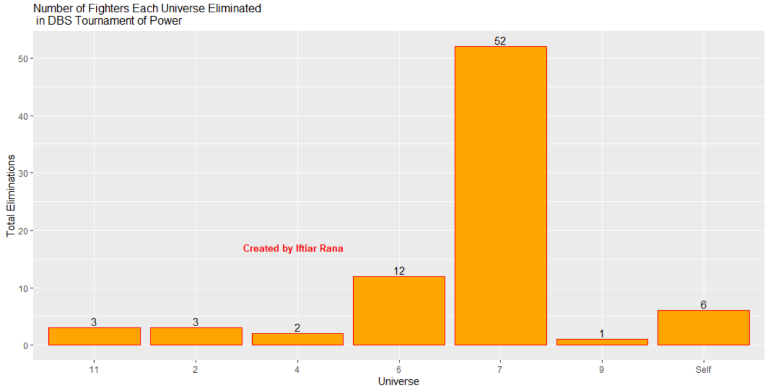

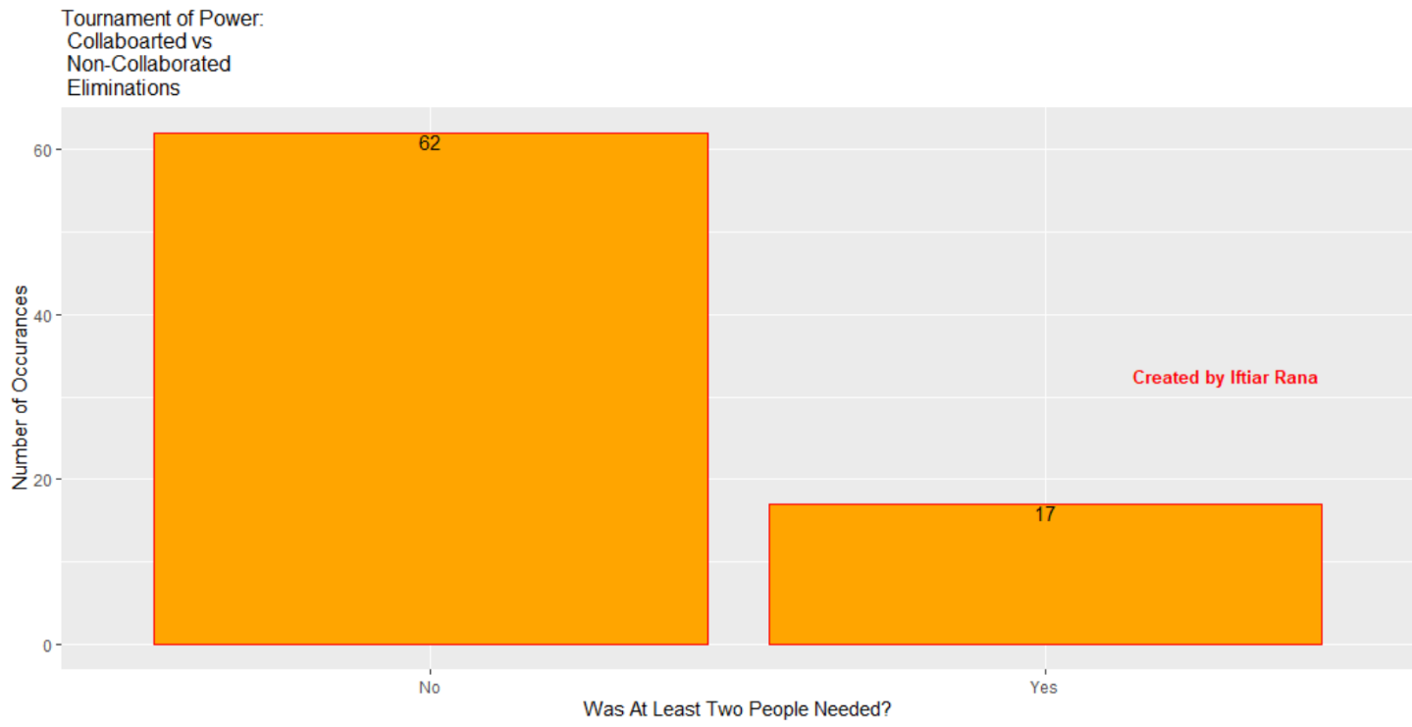

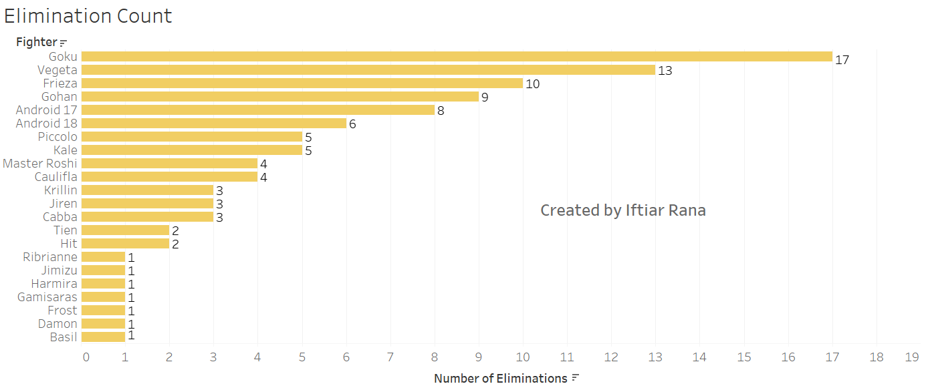

Note: The *Elimination Count* graph above also included collaborated eliminations (fighters were eliminated by 2 or more fighters)

**Analysis**

Based off the *Number of Fighters Each Universe Eliminated in DBS Tournament of Power*, it is clear that Universe 7 has the most eliminations. Universe 7 is where the main characters of the Dragonball Universe are from. Furthermore, it was Goku who pushed the idea for this tournament. Therefore, every other universe deity probably believed that they’re to blame for Zeno going forward with it. They were probably hoping that Zeno would simply forget this idea and not erase any of the universes. This would make Universe 7 major targets. Universe 9’s God of Destruction and Supreme Kai even sent out assassins to try and kill Goku and Frieza so Universe 7’s team is down 2 players. During the tournament itself Universe 9 targeted Universe 7, especially Goku, because they were humiliated in the Grand Zeno Exposition matches (Majin Buu defeated Basil, Goku defeated Bergamo, and Gohan and Lavender fought to a draw). Universe 3’s remaining also targeted Universe 7 because at that point, they had the most fighters remaining. Universe 7 also comprised of people who enjoy fighting (Goku, Vegeta, Frieza) and are martial artists (Master Roshi, Krillin, Tien). Even during the tournament, they split up to fight other contestants on their own. Seeking out battles armed with a huge target on their back, strong fighters, and plot armor them having the most eliminations is rational.

Universe 6 has the 2nd most elimination. Not surprised there either. Universe 6 was introduced early on in *Dragon Ball Super* when Champa visited Beerus and made a contest for the Super Dragon Balls. Botamo, Magetta, Hit, Frost, and Cabba were introduced as well. Kale and Caulifla came later on. They had more screen time than almost every other universe, except for 7. Not to mention both Universe 6 and 7 are twins; that means they have similar strengths and fighters (Saiyans, Nemekians, Aliens). Therefore, they should and were able to eliminate a good chunk of people.

There were noticeably a lot of people willing to eliminate themselves. One done so to escape from Frieza, the other from Master Roshi. However, the remaining four – Gohan, 18, Goku, and Frieza – sacrificed themselves to help eliminate another fighter. 18 was more indirect – she saved 17, who became a major key in finishing off Anilaza (the combined remaining 5 fighters from Universe 3). It goes to show the flight or fight response.

What was surprising is Universe 11 only getting 3 eliminations. Their universe is at a future time. Therefore, it would be logical to assume that they have advanced fighting skills. All of their fighters are Pride Troopers, their police force to fight evil. They also have Jiren, a mortal who’s stronger than a deity. Topp and Dyspo are also strong in their own rights as well. However, for the most part they were only fighting other strong fighters. If you fight other strong fighters and lose, your elimination count doesn’t go up. Not only that but after 5 of their troopers were out from fighting Kale and Caulifla, the remaining preserved their energy and only fought when necessary.

Universe 2 also had 3 eliminations. They were only in it for so long because they preserved their energy from the start and when they attacked, they couldn’t keep up with the other fighters. Preserve your energy means avoiding confrontation, hence less opportunities to eliminate other fighters.

Universe 9 was deemed the weakest universe by both Zenoes. They only had 1 elimination. Makes sense for them to not have many eliminations. Not to mention, their Supreme Kai had his ego hurt from the expo matches and ordered his team to go after Universe 7 – a grave mistake.

However, Universe 10 had no eliminations and they were initially ranked stronger than Universe 9 and 7. Maybe that could be due to their mortal development level being more reflected on the average mortal, who aren’t fighters. Meanwhile the other universes mortals are underdeveloped but have really strong fighters and who you bring to the table matters gravely.

Universe 3 also had no eliminations. While 18 was counted as an elimination for the Universe, I cannot because she was willing to go out to save her brother, 17. Otherwise, that’d be their elimination. Not very surprised here either. Universe 3 have severely underestimated their opponents’ abilities and powers.

Finally, Universe 4 has 2 eliminations. They had 2 tricky fighters who are either too small or can mask their energy from other fighters and sneakily eliminate them and both of them got eliminations. Their other mistake was charging head-on without scoping their foes. Their leader Ganos attacked Roshi despite seeing his strength as an attempt to get payback since he was involved in the elimination of 2 of his comrades.

The middle graph shows how many eliminations were collaborated and how many were not. Majority of eliminations were not collaborated. That means that most fighters were eliminated by one single fighter. Most of them were one on ones. Makes sense for majority of the eliminations to be non-collaborated.

The graph at the bottom, the one with how many eliminations each fighter has, has Goku on top. He is a main character, loves to fight, and is very strong. Vegeta being runner-up is no surprise either for the same reason as Goku. Actually, the ones with the most eliminations are fighters from Universe 7 is expected because they have the most elimination count. The lack of eliminations from Jiren is unsurprising as well. He only wants to fight the strongest fighters. Master Roshi was impressive, with four eliminations for someone his age.

In the end the data tells a story. Universe 7 was a huge target from the get-go and they rose to the occasion and won the tournament. **Despite their rankings, they showed that it’s who you bring to the ring that counts the most.** They have 2 full Saiyans (Goku, Vegeta), 1 half-Saiyan (Gohan), an alien (Frieza), Androids 17 & 18 – both have infinite energy and that type of energy is needed in a tournament where one’s stamina is a huge factor, a Nemekian (Piccolo, he can regenerate any body part cut off), and 3 regular, strong humans. All of them have a lot of experience in martial arts and fighting as each have partaken in at least one of them. The skills they gain helped them overcome their foes’ abilities. Universe 6 would be up there but for the most part their fighters are relatively inexperienced and young. Universe 2, 9, and 10 all seemed to be weak. Universe 4’s fighters have tricks up their sleeves. However, Universe 7 knows how to deal with hidden & small opponents. Universe 3 used their intellect. Smart move, but they severely underestimated how strong their foes were. Universe 11 Pride Troopers are strong and smart. They relied on teamwork to help. However, most of them were in the middle of the pack and got eliminated by strong fighters. The Tournament of Power showed that teamwork, experience, resolve, and strength is needed to win. If you lack one, then you will lose.